***Press Release***

**AIA Investment Management (Thailand) Co., Ltd. Celebrates 5th Anniversary with a Continued Commitment to Promoting Sustainable Wealth for Thai People**

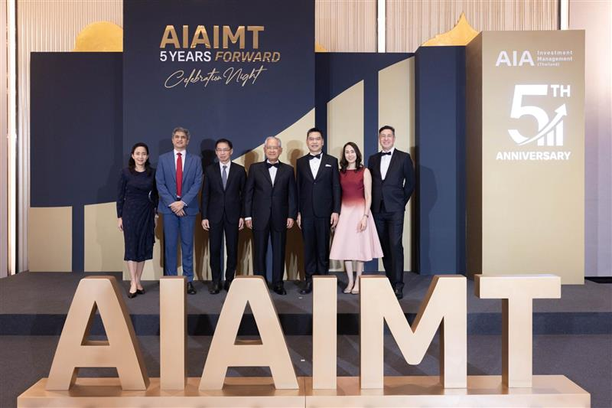

**AIA Investment Management (Thailand) Co., Ltd. (AIAIMT)** recently hosted a celebration to mark its 5th anniversary under the theme **“AIAIMT 5 Years Forward.”** The event reflected the company’s journey of trust and commitment to building a secure financial future for Thai people. **Mr. Sukkawat Prasurtying**, Chief Executive Officer of AIAIMT, warmly welcomed distinguished guests from the AIA Group, including **Dr. Narongchai Akrasanee,** IndependentNon-executive Director of AIA Group and Chairman of Advisory Board of AIA Thailand, **Dr. Mark Konyn**, Group Chief Investment Officer; **Mr. Tan Hak Leh**, Regional Chief Executive; and **Mr. Shrikant Shrinivas Bhat,** Chief Executive Officer, Group Unit-Linked and Pensions Business. In this occasion, **Ms. Alisa Simaroj**, Chief Agency Officer of AIA Thailand has led the executives, along with the agency force to join in congratulating the 5th anniversary of AIAIMT. The event took place at The Ritz-Carlton Hotel, Bangkok, on Friday, 12 September 2025.

As part of the celebration, AIAIMT also hosted an honorary award ceremony to recognise and thank AIA agents who have provided outstanding service to clients with the highest assets under management with AIAIMT. A total of 11 prestigious awards were presented to 10 top-performing AIA agents from various regions across the country. These awards reflect the professionalism and financial planning expertise of the agents in helping Thai people achieve long-term financial health and stability. Moreover, there were an exclusive mini concert by renowned singer **Toh Saksit Vejsupaporn**, adding a special touch of entertainment to the memorable event.

Established in 2020, AIA Investment Management (Thailand) Co., Ltd. (AIAIMT) is committed to driving the capital market forward with a focus on managing mutual funds under AIA Thailand’s Unit-Linked Insurance policies. By leveraging AIA’s global investment network, AIAIMT aims to connect Thai investors with international opportunities and elevate investment management standards to foster long-term, sustainable wealth across the country. Today, AIAIMT manages over THB 1 trillion in assets under management (AUM), making it the third-largest asset management company in Thailand*.

*Disclaimer:*

*\*Statistic from AIMC, as of July 2025*

*\*\*Past performance of AIA Investment Management (Thailand) Limited or a fund is not indicative of its future performance.*

*\*\*\*Investors should study the prospectus before making an investment decision.*

-END-

**Contacts for News Media:**

Corporate Communications, AIA Thailand

Ornnita Sirisuvanna Tel. 02 738 4620 Email [ornnita.sirisuvanna@aia.com](mailto:ornnita.sirisuvanna@aia.com)

Emisa Wongsiri Tel. 02 738 7962 Email [emisa-e.wongsiri@aia.com](mailto:emisa-e.wongsiri@aia.com)